Mossel Bay Aero Club

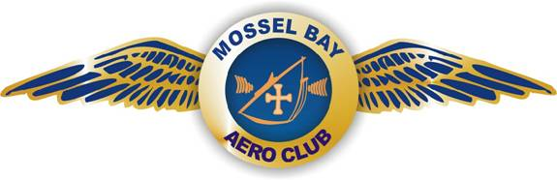

Dynamic Insurance Brokers

Poker Rally 2020

Route:

After early morning coffee and rusks at Mossel Bay we get airborne at +/- 07h30 and route to FACY (Still Bay) for quiche and salad , and of course that all important first card.
Thereafter we route to FASX for a homemade egg and mayonnaise or ham and cheese roll and the second card.
We then route to FARD (Riversdale) for a short break and the third card.
After which we route to Gelukshoop farm strip near Albertinia where owner Rinus Willemse will provide us with biltong and a cold drink/juice and the fourth card.
The final leg sees us route towards the Gouritz River Bridge, then south along the river on the western side and along the coast back to Mossel Bay for the fifth card and that welcome cold one and a light lunch.

Unfortunately, things have turned out differently this year as none of the local Clubs were able to “host” us.
Swellendam were able to provide the Breakfast on the Sunday, but not the Saturday.

Nonetheless I am very positive we will have fun, always great to fly in our beautiful part of the World.

Special Notes:

We have been asked to practise Noise Abatement in the Still Bay area and to keep our circuits to the North of the Field.

Please remember this is primarily a FUN event, it is not a race. If you are flying a fast aircraft you will no doubt overtake one or more aeroplanes, please thus take caution.

Please use landing lights on Landing at the various airfields, if congestion arises, please orbit and be patient.

Overberg Airspace: Frequency 119.80
Riversdale Airfield: 124.80
Swellendam: 124.80

